Title

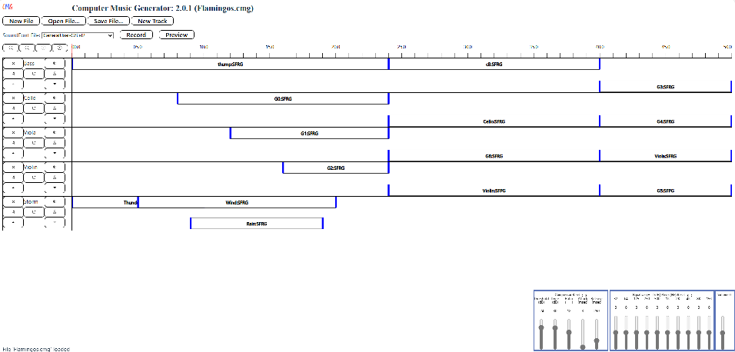
Generator
Room Compressor, Equalizer, and Volume
Status Message Area
Track Display and Control
File and Track Menus
Preview and Record Buttons
Timeline and Controls
SoundFont Selector

